Here is a comprehensive analysis of the sources and microbiology of abdominal abscesses and the guideline-recommended antibiotic regimens.
---
Most Common Sources of Intra-Abdominal Abscess
Abdominal abscesses most frequently arise from perforation or infection of gastrointestinal and hepatobiliary structures. The most common sources include:
- Appendicitis — perforated appendicitis is one of the leading causes, particularly in community-acquired infections.[1][2]
- Cholecystitis — complicated cholecystitis with perforation or biliary infection accounts for a large proportion of cases (36% in one series).[2]
- Colonic perforation/diverticulitis — perforated diverticulitis is a major source, especially in older adults, and tends to harbor more resistant organisms.[1][3]
- Postoperative complications — 10–28% of patients undergoing surgery for Crohn's disease present with intra-abdominal abscess; hepatobiliary surgery can also lead to abscess formation (up to 25% of hepatectomies).[4]
- Pyogenic liver abscess — the most common visceral abscess, accounting for nearly half of all visceral and >10% of all intra-abdominal abscesses. These arise from biliary infection (direct spread, ~50% of cases) or hematogenous seeding from appendicitis, diverticulitis, or even dental infections.[4]
- Penetrating or blunt abdominal trauma.[1]
---
Microbiology
These infections are characteristically polymicrobial, reflecting enteric flora, with the pathogen profile varying by source (proximal vs. distal GI) and setting (community vs. healthcare-associated).[5][6]
Community-acquired infections:
- Gram-negative aerobes: Escherichia coli (dominant, ~46% of isolates), Klebsiella pneumoniae (~10%), other Enterobacteriaceae[5][2]
- Anaerobes: Bacteroides fragilis group (predominant anaerobe), Peptostreptococcus spp., Clostridium spp. — more prevalent with distal GI sources[5][6]
- Gram-positive aerobes: Streptococcus (especially S. anginosus/milleri group), Enterococcus faecalis (~9%)[5][2]
Healthcare-associated infections shift toward more resistant organisms:[5]
- Increased Enterobacter spp., Pseudomonas aeruginosa, Acinetobacter spp.
- Higher prevalence of Enterococcus spp. (including VRE) and Staphylococcus aureus (including MRSA)
- Greater incidence of Candida spp., especially after prior broad-spectrum antibiotics
- ESBL-producing Enterobacteriaceae are increasingly common even in community-acquired infections (30% of gram-negatives in one recent series)[2]
---
Empiric Antibiotic Regimens
The Surgical Infection Society (SIS) guidelines stratify empiric therapy by patient risk and acquisition setting:[5][7]
Patient Category | Preferred Regimens | Alternatives | References
Lower-risk, community-acquired | Ceftriaxone + metronidazole; or ertapenem monotherapy | Ciprofloxacin + metronidazole (β-lactam allergy); moxifloxacin monotherapy | [1]
Higher-risk, community-acquired | Piperacillin-tazobactam; imipenem-cilastatin; meropenem; or cefepime + metronidazole | Ceftazidime + metronidazole; add ampicillin or vancomycin for enterococcal coverage if not using pip-tazo or imipenem | [1]
Healthcare-associated | Piperacillin-tazobactam (± vancomycin/linezolid); or meropenem + ampicillin for MDRO risk | Ceftazidime-avibactam + metronidazole (for ESBL/resistant organisms) | [2], [3]
β-Lactam allergy | Aztreonam + metronidazole + vancomycin | Fluoroquinolone + metronidazole (lower-risk only) | [1]
Key pharmacologic considerations:
- Piperacillin-tazobactam demonstrated the highest abscess penetration ratio (median CIAA/Cplasma of 2) in a prospective study, with 75–80% pharmacodynamic target achievement, comparable to meropenem.[10]
- A network meta-analysis of 45 RCTs (14,267 patients) found cefepime + metronidazole to be the most effective regimen overall for complicated IAI, with lower all-cause mortality than tigecycline.[11]
- Empiric antifungal therapy is generally not recommended, except in critically ill patients with upper GI perforations where Candida peritonitis risk is high.[5][8]
---
Duration of Therapy
The landmark STOP-IT trial (NEJM, 2015) demonstrated that 4 days of antibiotics after adequate source controlproduced equivalent outcomes to a traditional ~8-day course (composite endpoint of SSI, recurrent IAI, or death: 21.8% vs. 22.3%).[12]
“In this randomized study involving patients with complicated intraabdominal infections, a fixed duration of 4 days of antibiotic treatment resulted in outcomes that were similar to those of a traditional, longer course that was based on resolution of physiological abnormalities, and the shorter course was associated with significantly fewer days of antibiotic exposure.” — Robert G. Sawyer, M.D., et al.University of Virginia Health System and other institutions
The STOP-IT findings were consistent across subgroups including higher illness severity, healthcare-associated infections, and different source control methods:
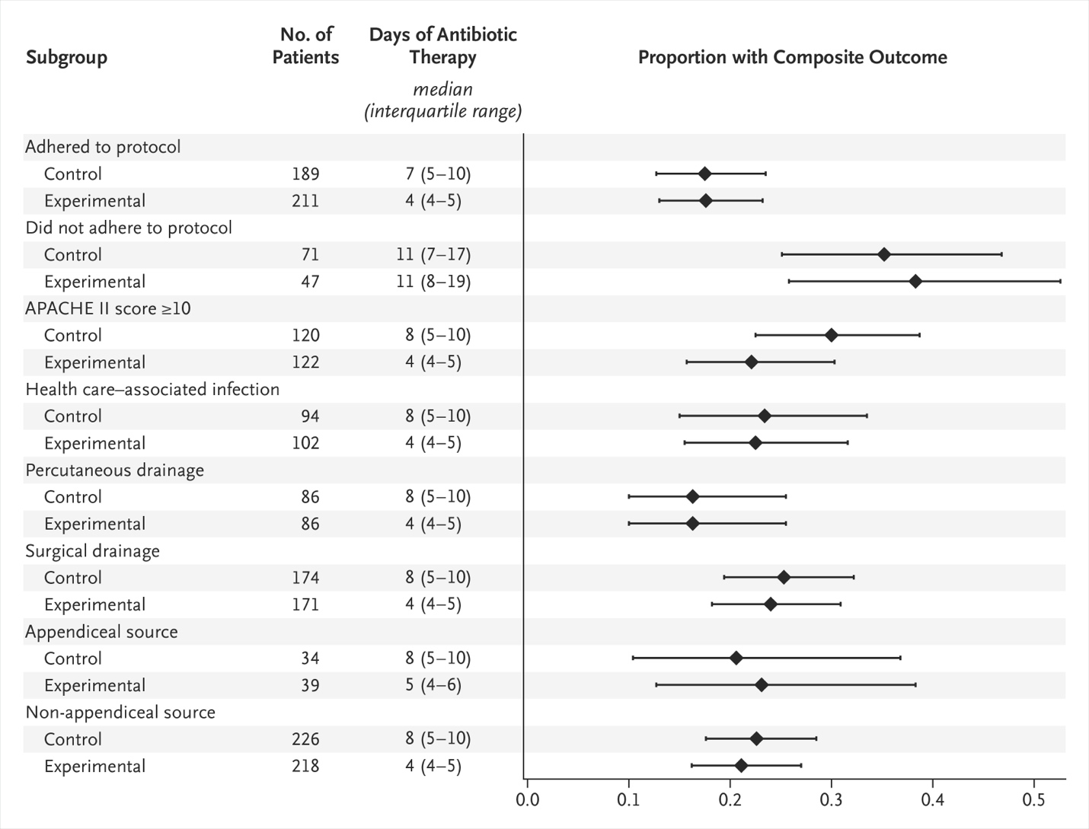Figure 3 Primary Composite Outcome in Key Subgroups. undefined
Current guideline recommendations for duration:[5][7]
- Adequate source control achieved: ≤4 days (96 hours)[5]
- Source control not possible: 5–7 days, with reassessment for intervention[5]
- Critically ill patients (ICU): ≤8 days after source control (2024 SIS update)[7]
- Secondary bacteremia from IAI: ≤7 days if source controlled and no longer bacteremic[5]
- Uncomplicated IAI (e.g., non-perforated appendicitis/cholecystitis): ≤24 hours postoperatively[5]
---
Would you like to explore the specific management approach for ESBL-producing or multidrug-resistant organisms in intra-abdominal infections, including carbapenem-sparing strategies?

References
- Management of Intra-Abdominal Sepsis. Nichols RL. The American Journal of Medicine. 1986;80(6B):204-9. doi:10.1016/0002-9343(86)90502-4.
- The Aetiologic Agents and Resistance Rates in Community-Acquired Complicated Intra-Abdominal Infections: Where Are We Locally?. Ozturk E, Akdemir I, Ontas E, et al. Diagnostic Microbiology and Infectious Disease. 2025;113(4):117023. doi:10.1016/j.diagmicrobio.2025.117023.
- The Appropriateness of Ceftriaxone and Metronidazole as Empirical Therapy in Managing Complicated Intra-Abdominal Infection-Experience From Western Health, Australia. Tan A, Rouse M, Kew N, et al. PeerJ. 2018;6:e5383. doi:10.7717/peerj.5383.
- Gastrointestinal Surgical Emergencies Textbook. Ashley E. Aaron, Andrea Amabile, Ciro Andolfi, et al. American College of Surgeons (2021).
- The Surgical Infection Society Revised Guidelines on the Management of Intra-Abdominal Infection. Mazuski JE, Tessier JM, May AK, et al. Surgical Infections. 2017;18(1):1-76. doi:10.1089/sur.2016.261.
- Microbiology and Management of Abdominal Infections. Brook I. Digestive Diseases and Sciences. 2008;53(10):2585-91. doi:10.1007/s10620-007-0194-6.
- The Surgical Infection Society Guidelines on the Management of Intra-Abdominal Infection: 2024 Update. Huston JM, Barie PS, Dellinger EP, et al. Surgical Infections. 2024;25(6):419-435. doi:10.1089/sur.2024.137.
- Fever and Infections in Surgical Intensive Care: An American Association for the Surgery of Trauma Critical Care Committee Clinical Consensus Document. Nohra E, Appelbaum RD, Farrell MS, et al. Trauma Surgery & Acute Care Open. 2024;9(1):e001303. doi:10.1136/tsaco-2023-001303.
- The Management of Intra-Abdominal Infections From a Global Perspective: 2017 WSES Guidelines for Management of Intra-Abdominal Infections. Sartelli M, Chichom-Mefire A, Labricciosa FM, et al. World Journal of Emergency Surgery : WJES. 2017;12:29. doi:10.1186/s13017-017-0141-6.
- Antibacterial and Antifungal Drug Concentrations in Intra-Abdominal Abscesses: A Prospective Clinical Study. Cancela Costa A, Grass F, Andres Cano I, et al. Antimicrobial Agents and Chemotherapy. 2025;69(1):e0117824. doi:10.1128/aac.01178-24.
- Efficacy, Safety, and Tolerability of Antimicrobial Agents for Complicated Intra-Abdominal Infection: A Systematic Review and Network Meta-Analysis. Kong W, Deng T, Li S, Shu Y, Wu Y. BMC Infectious Diseases. 2023;23(1):256. doi:10.1186/s12879-023-08209-9.
- Trial of Short-Course Antimicrobial Therapy for Intraabdominal Infection. Sawyer RG, Claridge JA, Nathens AB, et al. The New England Journal of Medicine. 2015;372(21):1996-2005. doi:10.1056/NEJMoa1411162.

